**CIS 435 - Project 4**

**By: Athira Nakkara Radhakrishnan**

**Tutorial: Find the Winner – Christmas Raffle**

**Date: 12/15/2024**

**Tutorial: How to Use the Christmas Raffle**

**Web Application**

**Introduction & Overview**

Welcome to the Christmas Raffle Web Application! This system allows users to enter a Christmas raffle by providing their details and receiving a unique raffle ticket number. The admin has access to a dashboard to manage the raffle tickets, view total sales, and select a random winner. The winner will be notified by email.

**Few steps to know before starting:**

* Launch the XAMPP application on your computer, click Start next to both Apache and MySQL.
* Wait until both services show "Running" in green. This ensures that the web server (Apache) and the database server (MySQL) are active and ready to serve your application.
* Open web browser, in the address bar, type http://localhost/christmas_raffle/login.html to access the application, you should be able to see the login page of the Christmas Raffle System
* In the browser, enter <http://localhost/christmas_raffle/admin.php> to go directly to the admin dashboard

**Step 1: Logging In**

Before you can enter the raffle, you need to log in using your username and password. This helps ensure that only registered users can participate in the raffle.

* **Username:** Enter your assigned username (for example, testuser1)
* **Password:** Enter your password (for example, password123)

The login page will prompt you for your credentials, and once submitted, you will be redirected to the raffle registration form.

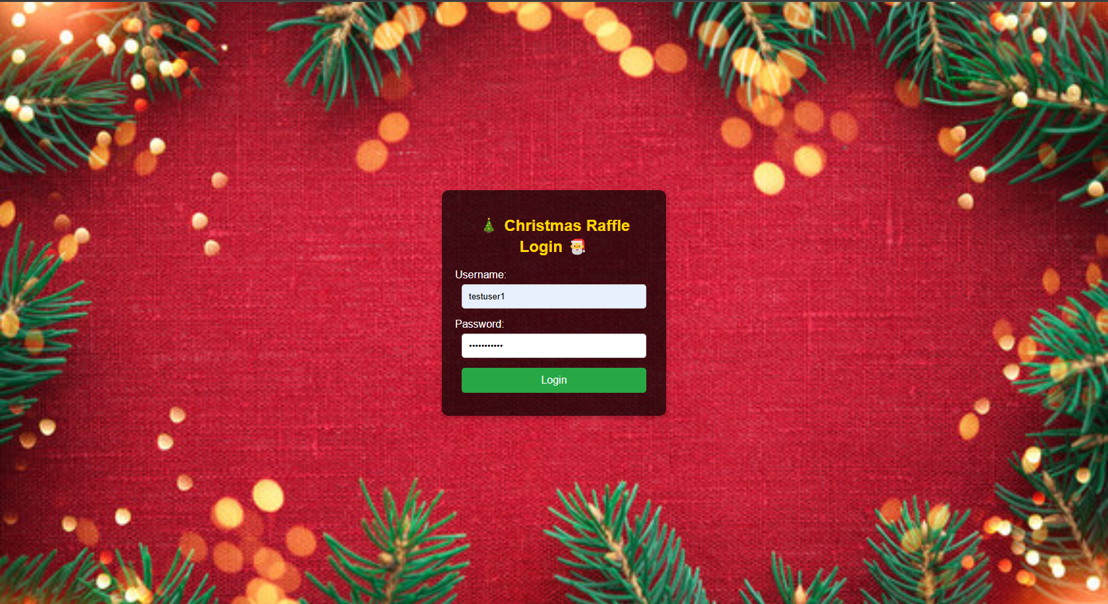

**Step 2: Accessing the Registration Form**

Once logged in, you will be directed to the raffle registration form. This page collects basic details such as first name, last name, phone number, and email address.

* **First Name**: Enter your first name.
* **Last Name**: Enter your last name.
* **Phone Number**: Provide your contact number.
* **Email Address**: Provide a valid email address.

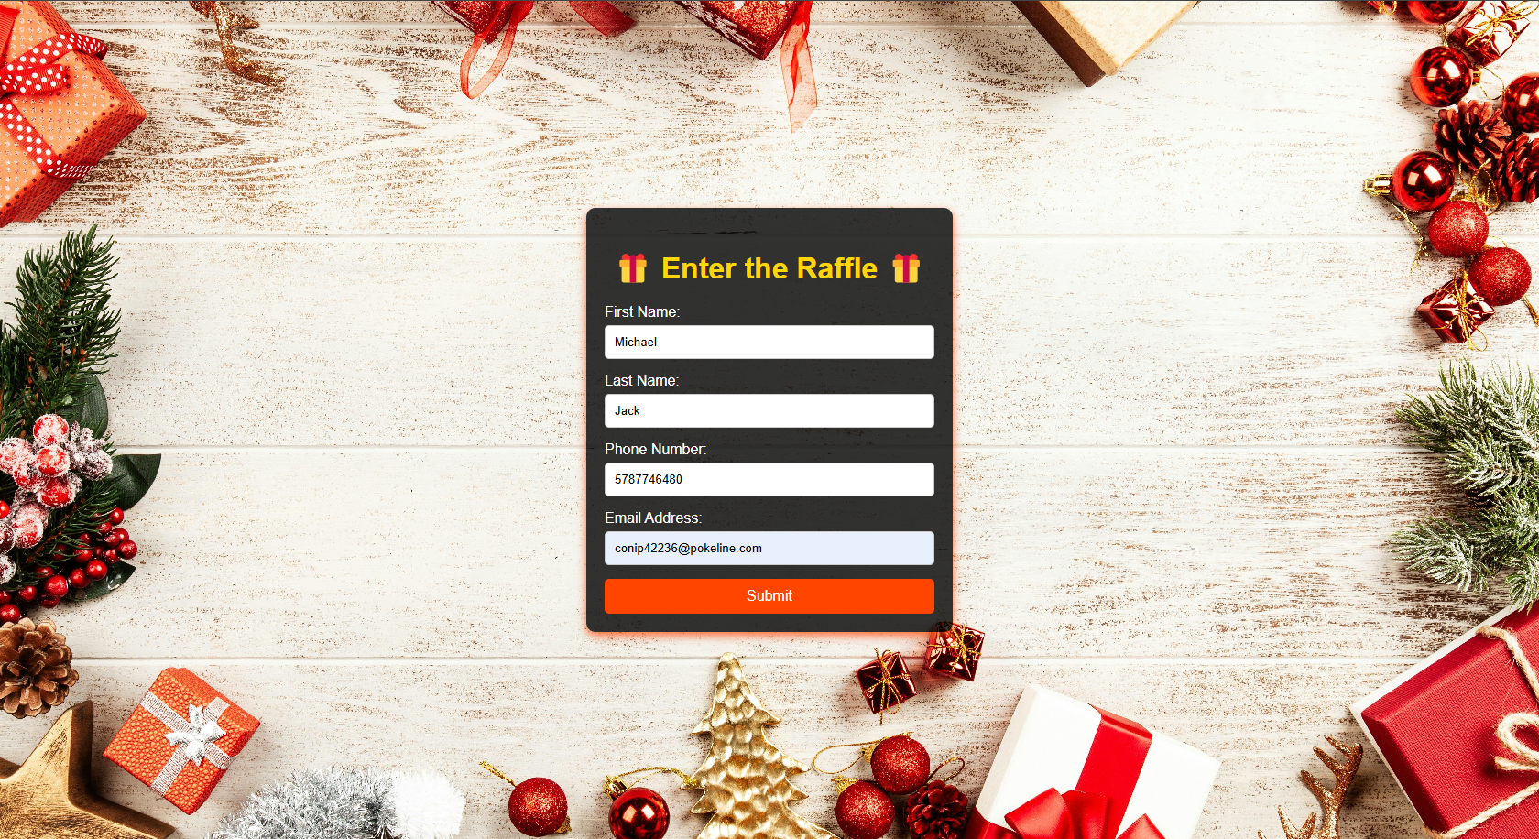

**Step 3:** **Submitting the Form**

Once all fields are filled out, click on the "Submit" button. Upon submission, your data will be saved to the database, and a unique raffle ticket number will be assigned to you.

**Step 4:** **Viewing Your Raffle Ticket**

After successfully submitting your form, you will be redirected to a page where your unique raffle ticket number is displayed.

* Your raffle ticket number will be shown along with a congratulatory message.

You can bookmark this page or take a screenshot for future references.

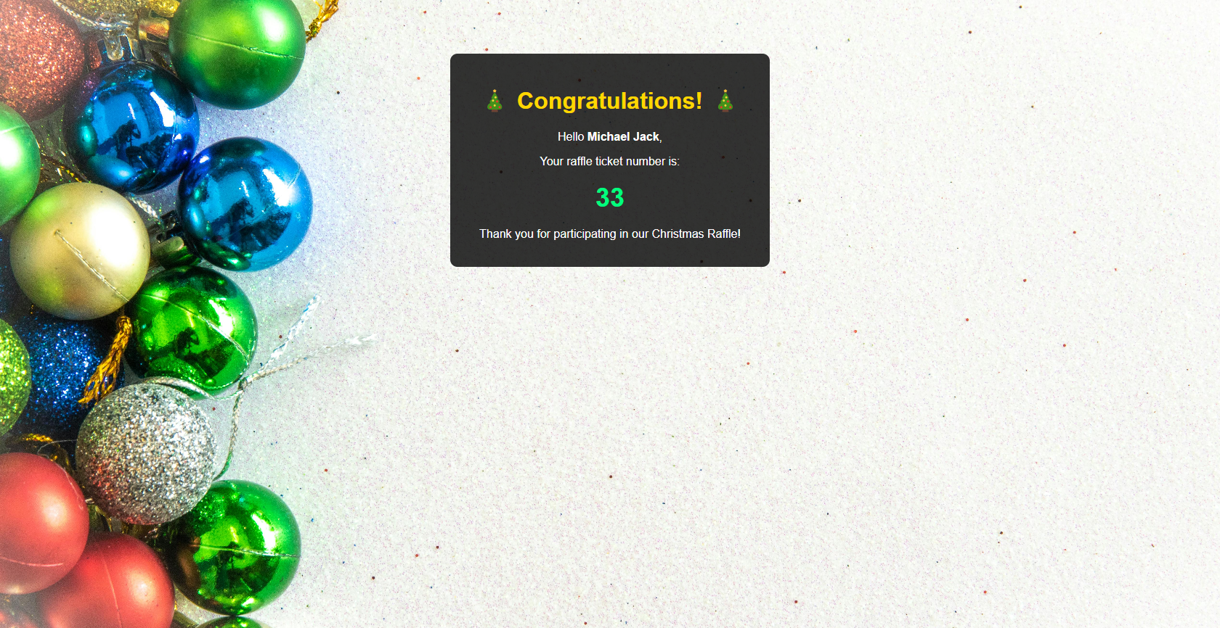

**Step 5: Admin Dashboard**

Admins have access to the backend dashboard to view total tickets sold and randomly select a winner. Visit the Admin Dashboard page. This page will display:

* **Total Tickets Sold:** This section shows how many users have entered the raffle
* **Select Random Winner:** This feature allows the admin to pick a winner randomly from the list of registered users.

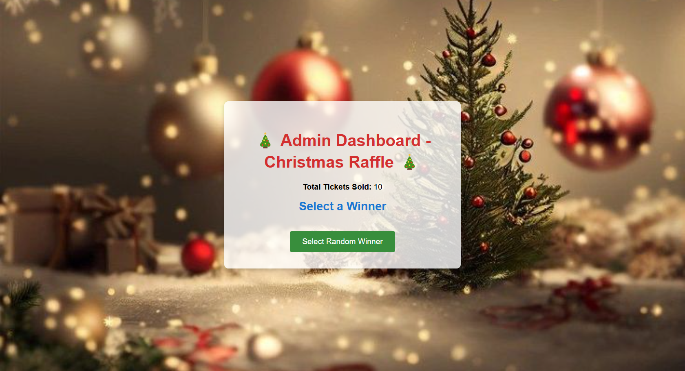

**Step 6: Selecting a Winner**

After reviewing the total tickets sold, the admin can click on the “Select Random Winner” button to automatically select a winner. Once the winner is chosen, the system will send an email notification to the winner’s email address with the prize details.

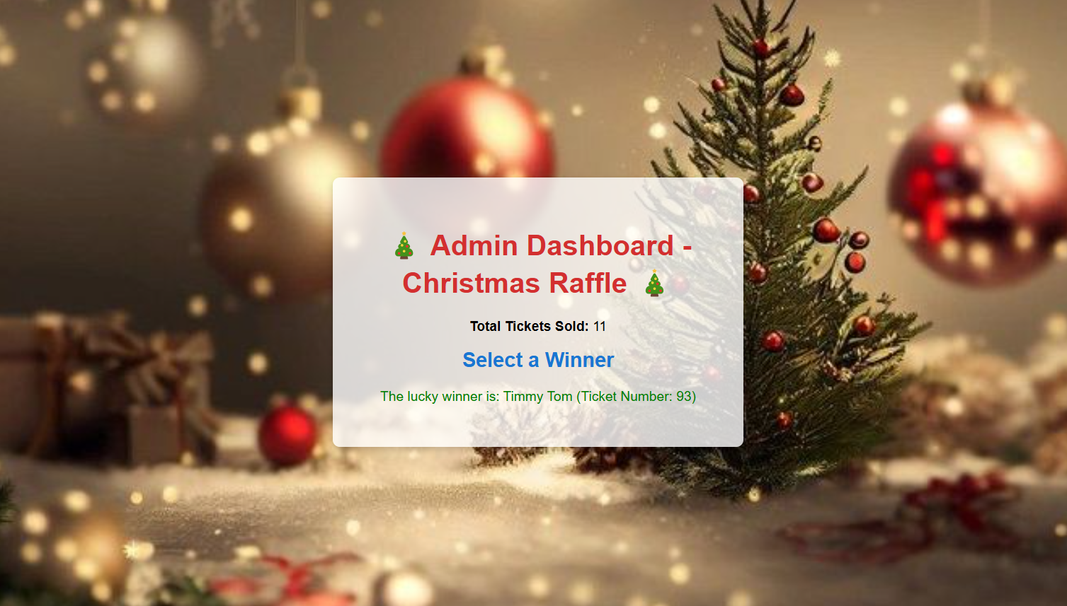

**Step 7:** **Email Notification to Winner**

Once a winner is selected, the system will automatically send an email to the winner. The email contains:

* A congratulatory message.
* The winner’s raffle ticket number.
* The prize details.

This email ensures the winner is notified in a timely manner.

